Copious: in large amounts; abundant (adjective)

Countenance: appearance, especially the expression of the face (noun)

Consternation: a state of paralyzing dismay; fear (noun)

Scruple: feeling of uneasiness or guilt that keeps a person from doing something (noun)

Nominal: in name only but not in reality (adjective)

Pestilential: deadly; poisonous (adjective)

Slavery was a common practice widespread in Africa, and it still continues in some countries today.

African merchants sold slaves, so therefore some Africans did participate willingly in the slave trade.

Well over 90 percent of enslaved Africans were imported into the Caribbean and South America. Only about 6 percent of African captives were sent directly to British North America. Yet by 1825, the US had a quarter of blacks in the New World.

Captured Africans were packed like cargo into slave ships.
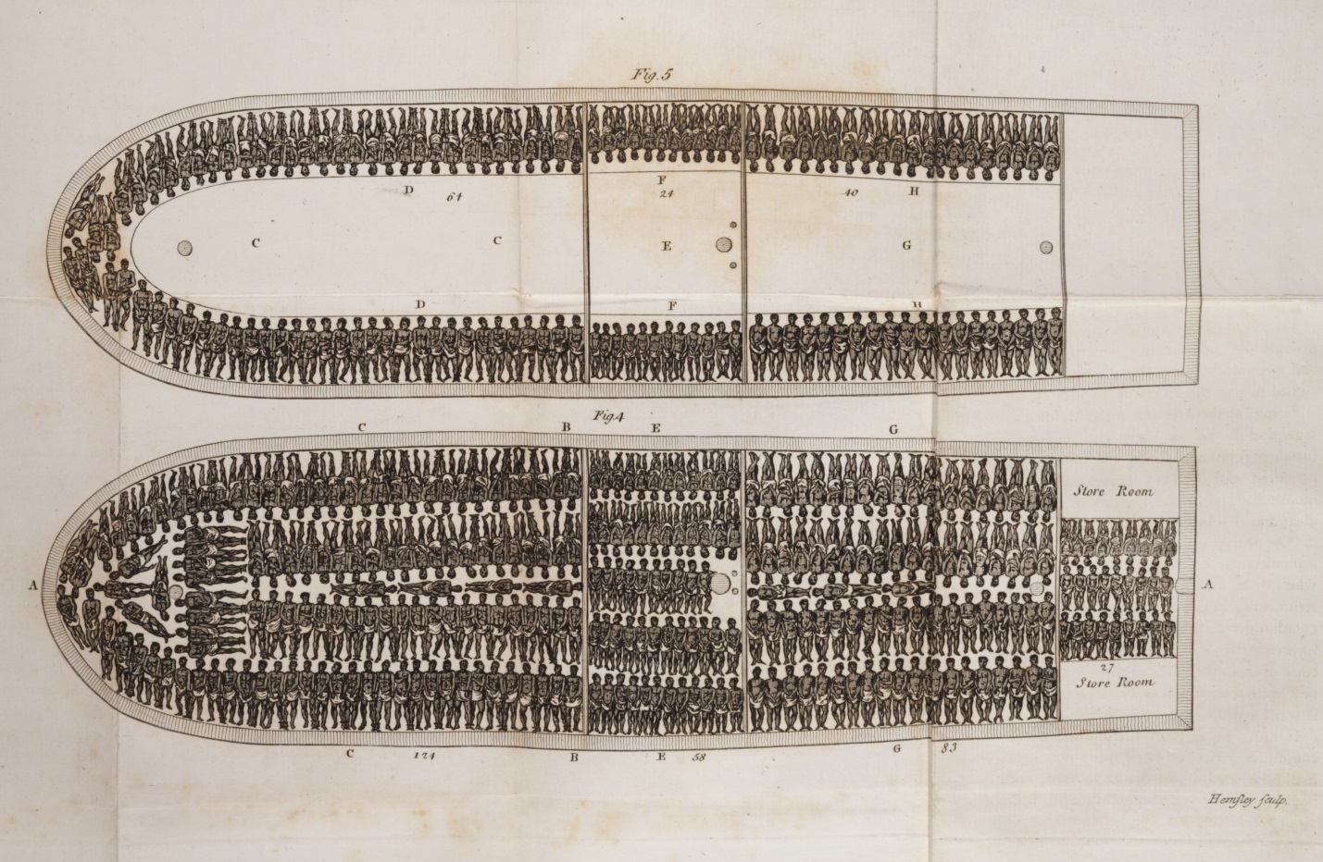

Slave traders rarely sold families as a single group.

